ECS Task

1. Setup a highly available ecs cluster with load balancer and dynamic port mapping.
NOTE:
Your cluster should maintain atleast 6 tasks at any point of time and should be highly availble across multiple AZ's.
Use the below image from deployment:
sabair0509/hiring-app:works

1. Objective
The objective of this task is to deploy the hiring-app application on Amazon ECS with EC2 capacity, place an Application Load Balancer (ALB) in front of the ECS tasks, and configure the environment for high availability across multiple Availability Zones (AZs).
Application image used:
sabair0509/hiring-app:works
Target architecture:
Internet
|
|
Application Load
Balancer
|
|
Target Group (IP)
|
┌─────────────┴─────────────┐
| |
ECS Task 1 ECS Task 2
AZ: us-east-1a AZ: us-east-1b
Port: 8080 Port: 8080
| |
Tomcat Tomcat
| |
/hiring/ /hiring/
The final requirement is to maintain at least 6 ECS tasks and distribute them across multiple AZs.

2. Prerequisites
Before creating ECS resources, the following infrastructure was prepared:
- AWS account
- VPC
- Internet Gateway
- Public subnets
- Private subnets
- NAT Gateway
- Security Groups
- IAM role
- Docker image available in Docker Hub
Application image:
sabair0509/hiring-app:works

3. VPC and Subnet Configuration
A VPC was configured using the 10.0.0.0/16 CIDR range.
The following subnets were created:
Subnet | Availability Zone | CIDR
Public-1 | us-east-1a | 10.0.3.0/24
Public-2 | us-east-1b | 10.0.4.0/24
Private-1 | us-east-1a | 10.0.11.0/24
Private-2 | us-east-1b | 10.0.12.0/24

Important
Initially, a subnet CIDR overlap error was encountered:
CIDR Address overlaps with existing Subnet CIDR: 10.0.1.0/24
This was resolved by selecting unused CIDR ranges.
The final subnet configuration avoids overlapping CIDRs.

4. Internet Gateway
An Internet Gateway was created and attached to the VPC.
The Internet Gateway allows resources in the public subnets to communicate with the Internet.
Architecture:
VPC
|
└── Internet Gateway
The public subnets use a route through the Internet Gateway.

5. NAT Gateway
A NAT Gateway was configured for outbound Internet access from private subnets.
The purpose of the NAT Gateway is to allow resources in private subnets to access the Internet without making those resources directly accessible from the Internet.
Architecture:
Private Subnet
|
↓
NAT Gateway
|
↓
Internet Gateway
|
↓
Internet
This is useful for ECS EC2 instances/tasks that need to pull container images or access external services while remaining private.

6. Security Groups
Security Groups were configured for the ALB and ECS tasks.

6.1 ALB Security Group
The ALB Security Group allows incoming application traffic.
The important rule configured between the ALB and ECS tasks is:
Type: Custom TCP
Protocol: TCP
Port: 8080
Source: ECS/ALB security-group relationship
Outbound traffic:
Type: All traffic
Protocol: All
Destination: 0.0.0.0/0

6.2 ECS Task Security Group
The ECS task Security Group allows traffic from the ALB to the application port.
Inbound:
Type: Custom TCP
Protocol: TCP
Port: 8080
Source: hiring-alb-sg
Outbound:
Type: All traffic
Protocol: All
Destination: 0.0.0.0/0
This provides the following traffic flow:
Internet
|
↓
ALB
|
| TCP 8080
↓
ECS Task

7. IAM Role
An ECS task execution IAM role was configured:
ecsTaskExecutionRole
This role allows ECS tasks to perform required operations such as pulling images and sending container logs to CloudWatch.

8. ECS Cluster Creation
An ECS cluster was created:
Cluster Name:
hiring-app-cluster

Create ECS Cluster
Go to:
AWS Console
→ ECS
→ Clusters
→ Create cluster

1. Cluster name
Enter:
hiring-app-cluster
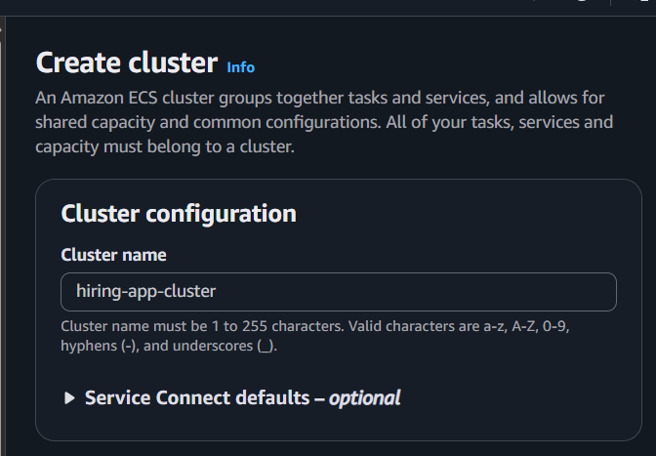

2. Infrastructure
Under Infrastructure, select:
☑ Amazon EC2 instances
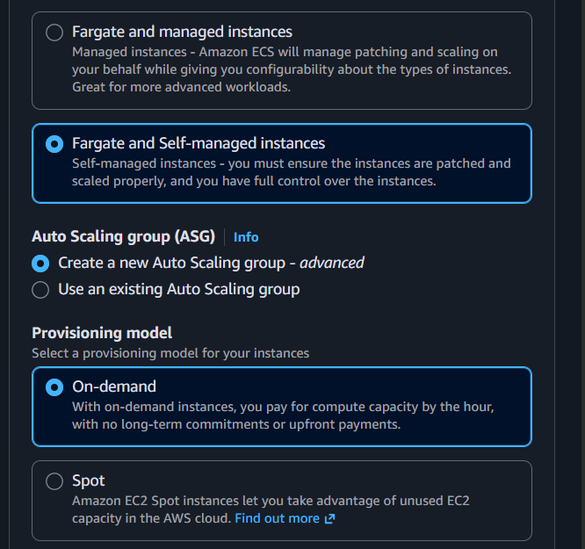

3. EC2 instance configuration
You should see an EC2 instance configuration section.

Operating system
Use:
Amazon Linux 2023
Prefer the ECS-optimized Amazon Linux 2023 AMI if the console provides the choice.

Architecture
Use:
x86_64
unless your Docker image specifically requires ARM.

Instance type
For your lab:
t3.small
You need enough CPU/memory to run 6 application containers.

4. Desired EC2 capacity
Set:
Desired capacity: 2
Minimum capacity: 2
Maximum capacity: 2
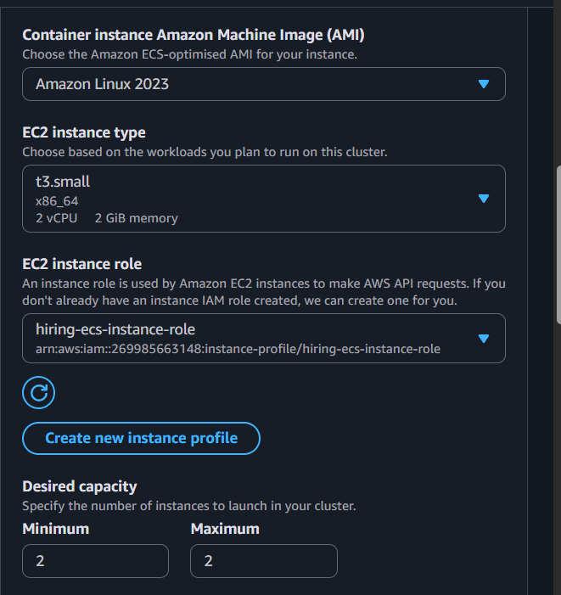

5. Networking
Select your existing VPC:
VPC:
10.0.0.0/16
For the subnets, select the private subnets:
☑ Private-1
10.0.11.0/24
us-east-1a

☑ Private-2
10.0.12.0/24
us-east-1b
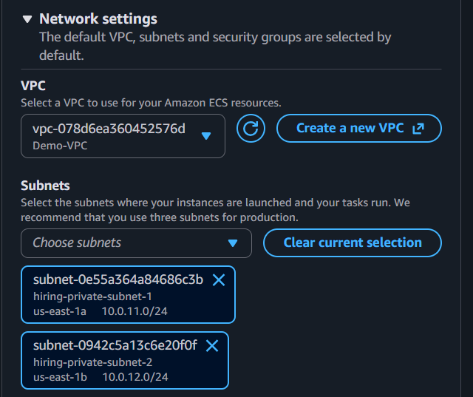
This is the preferred architecture:
Internet
|
Internet Gateway
|
+-------+-------+
| |
Public-1 Public-2
| |
ALB-A ALB-B
|
NAT Gateway
|
+------+------+
| |
Private-1 Private-2
AZ-a AZ-b
| |
ECS EC2 ECS EC2

6. Security Group
Select the ECS security group we created earlier:
hiring-ecs-sg

7. IAM role
For the EC2 instance profile/role, select the role you created:
hiring-ecs-instance-role
This allows the ECS agent on the EC2 instances to communicate with ECS.

8. SSH key pair
If the console asks for an SSH key pair, you can select an existing key pair that you already have access to.
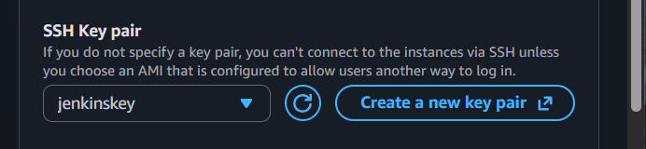

9. Auto Scaling Group
If the cluster creation wizard shows an Auto Scaling Group configuration, use:
Minimum capacity: 2
Desired capacity: 2
Maximum capacity: 2
Why?
Because we want:
AZ-a → EC2-1
AZ-b → EC2-2
However, make sure the Auto Scaling Group spans both subnets/AZs. We don't want both instances accidentally landing in the same AZ.

10. Create the cluster
Review the configuration.
You should roughly have:
Cluster name:
hiring-app-cluster

Infrastructure:
EC2

Instances:
4

VPC:
10.0.0.0/16

Subnets:
10.0.11.0/24
10.0.12.0/24

Security group:
hiring-ecs-sg

IAM role:
hiring-ecs-instance-role
Then click:
Create
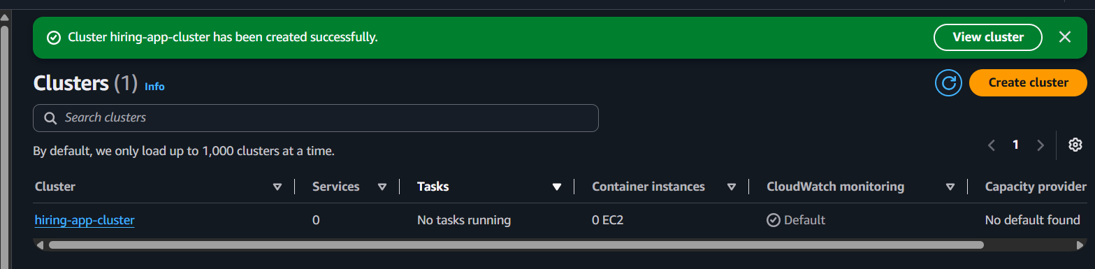

11. Wait for EC2 instances
After the cluster is created, go to:
ECS
→ Clusters
→ hiring-app-cluster
→ Infrastructure
You should eventually see:
Container instances: 4
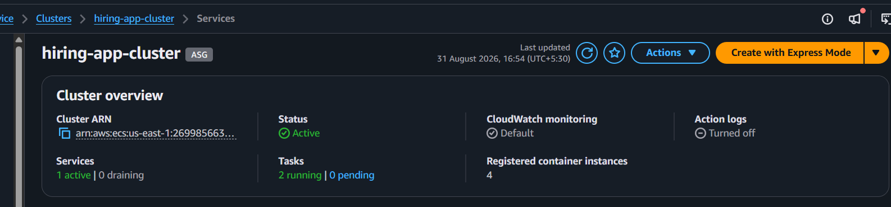
And in EC2:
EC2
→ Instances
you should see your ECS instances.
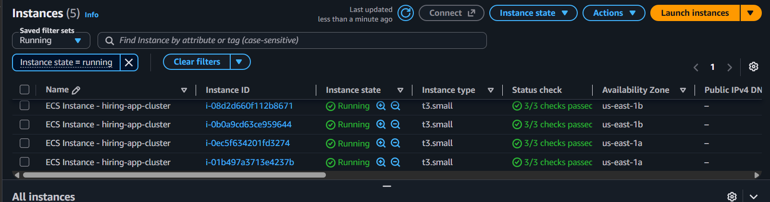

12. Verify the ECS instances
Container Instance 1
AZ: us-east-1a
Status: ACTIVE

Container Instance 2
AZ: us-east-1b
Status: ACTIVE
The ECS cluster should show something like:
Cluster
hiring-app-cluster

Container instances:
4

Running tasks:
0
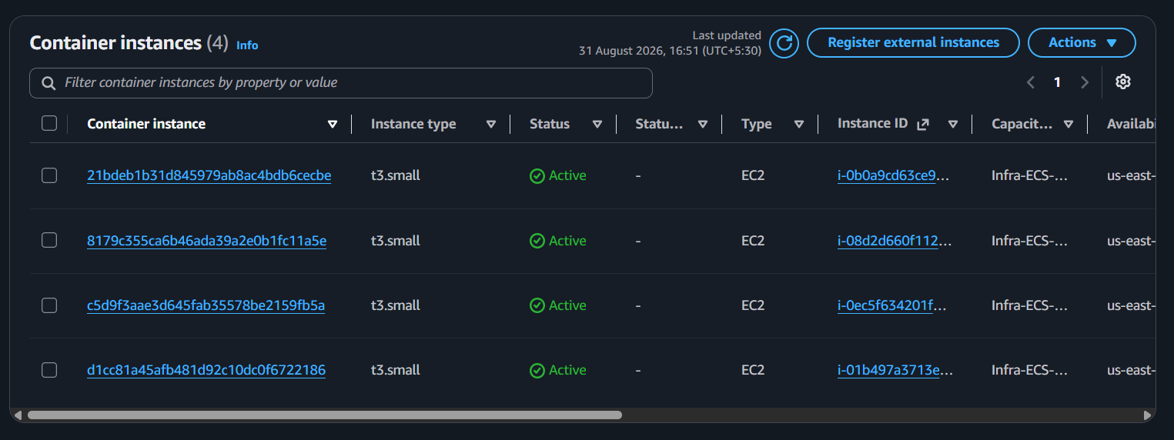

The cluster was configured with EC2 capacity rather than Fargate-only capacity.
The cluster contains an EC2 Auto Scaling capacity provider.
Capacity providers available in the cluster included:
Fargate
Fargate Spot
EC2 Auto Scaling
The EC2 Auto Scaling capacity provider is used for the ECS service.

9. ECS Task Definition
A task definition was created:
Task Definition:
hiring-app-task
Revision:
1
The application container uses:
Image:
sabair0509/hiring-app:works
CPU and memory configuration:
CPU:
0.5 vCPU

Memory:
1 GiB

Create the ECS Task Definition
Go to:
AWS Console
→ ECS
→ Task definitions
→ Create new task definition

1. Task definition family
Enter:
hiring-app-task
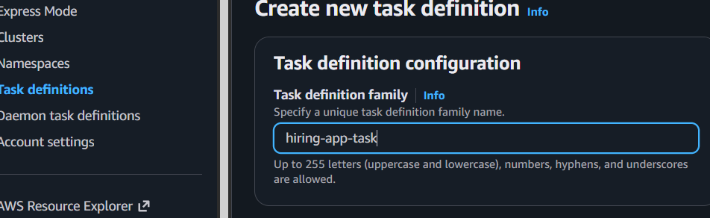

2. Launch type / infrastructure
Because our cluster has EC2 capacity, choose the option for:
Amazon EC2 instances
If the console shows a choice such as AWS Fargate / EC2, select EC2.

3. Task size
For this lab, start with:
CPU:
0.5 vCPU

Memory:
1 GB
If the console represents CPU as units, use:
512 CPU units
and memory:
1024 MiB
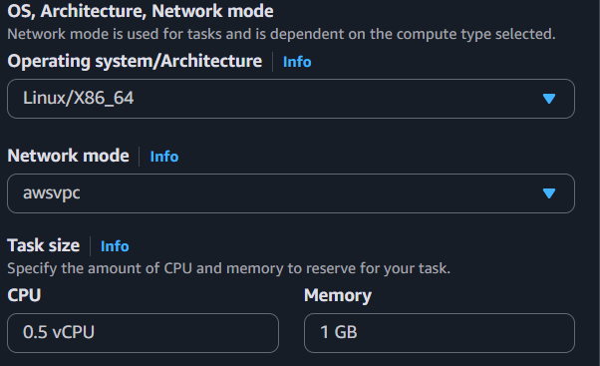

4. Task execution role
For the execution role, select:
ecsTaskExecutionRole
If you don't have one, we'll create it.
It normally has:
AmazonECSTaskExecutionRolePolicy
attached.
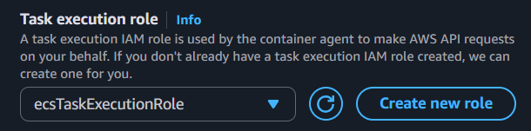

5. Add container
Click:
Add container
Container name:
hiring-app
Image URI:
sabair0509/hiring-app:works
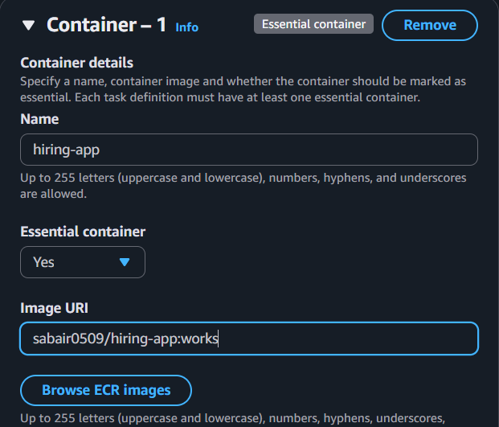

6. Port mapping — IMPORTANT
This is where we configure dynamic port mapping.
Enter:
Container port:
8080

Protocol:
TCP

Host port:
0
So the final configuration is:
Container port = 8080
Host port = 0
Protocol = TCP
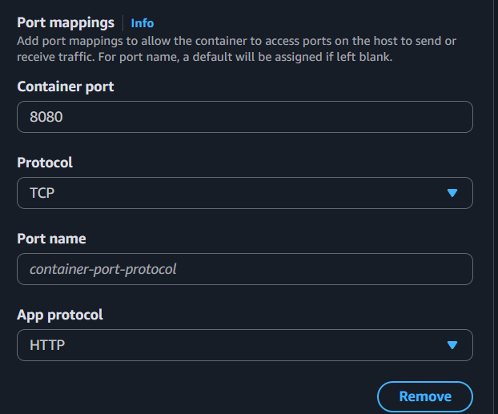

Why 0?
Your application listens inside the container on:
8080
ECS/Docker will automatically select an available host port.
For example:
EC2 Instance 1

Task 1:
Host 32768 → Container 8080

Task 2:
Host 32769 → Container 8080

Task 3:
Host 32770 → Container 8080
Another EC2 instance could have:
EC2 Instance 2

Task 4:
Host 32768 → Container 8080

Task 5:
Host 32769 → Container 8080

Task 6:
Host 32770 → Container 8080
This is exactly what the task means by dynamic port mapping.

7. Container health check
Don't add a Docker health check unless we know the image has one configured.
The ALB target group health check will be configured later.
We'll use something like:
Protocol: HTTP
Port: traffic port
Path: /

8. Logging
For a basic lab, enable:
Log driver:
awslogs
If the console asks for a log group, we can create:
/ecs/hiring-app
This allows you to see application logs in CloudWatch.
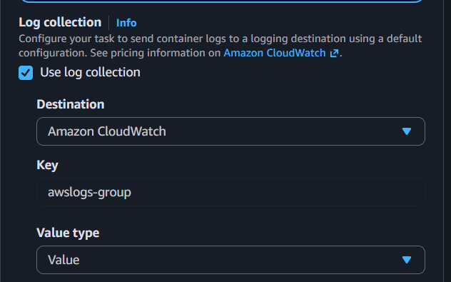

9. Create the task definition
Before clicking Create, verify:
Task definition:
hiring-app-task

Launch:
EC2

CPU:
512

Memory:
1024 MiB

Container:
hiring-app

Image:
sabair0509/hiring-app:works

Container port:
8080

Host port:
0

Protocol:
TCP

Execution role:
ecsTaskExecutionRole
Then click:
Create
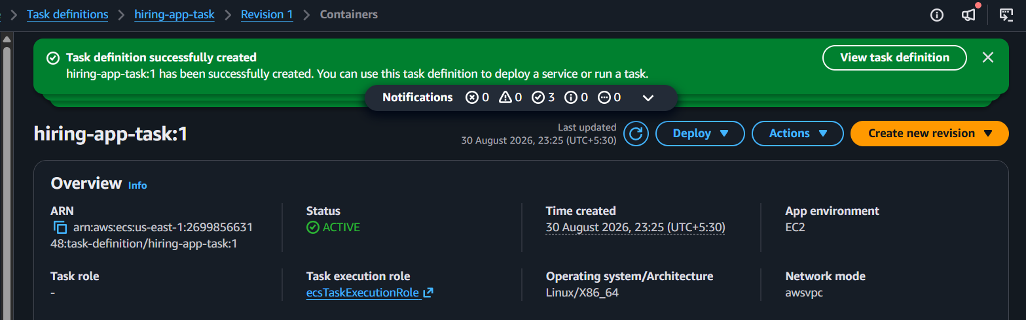

Successfully created task definition

10. Docker Image Pull and Container Configuration
The ECS task definition uses the Docker image:
sabair0509/hiring-app:works
When ECS started the task, the ECS container agent on the EC2 instance automatically pulled the image from Docker Hub.

Image pull process
Docker Hub
|
| sabair0509/hiring-app:works
↓
ECS EC2 Instance
|
↓
Docker Image
|
↓
ECS Container
|
↓
Tomcat :8080
The ECS task lifecycle confirmed that the image was successfully downloaded:
Task lifecycle:

Created
↓
Provisioning
↓
Pending
↓
Pull started
↓
Pull completed
↓
Activating
↓
Running
The task showed:
Pull started: 31 August 2026, 00:14
Pull completed: 31 August 2026, 00:14
Pull duration: 7 seconds
This confirms that ECS successfully pulled the application image before starting the container.
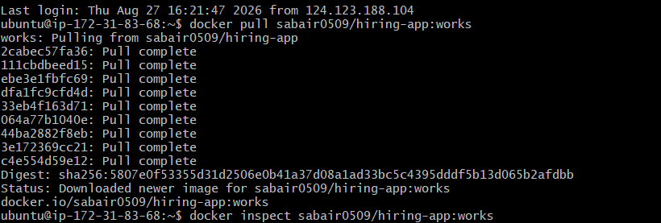

Container Configuration
Container name:
hiring-app
Container image:
sabair0509/hiring-app:works
Port mapping:
Container port: 8080
Host port: 8080
Protocol: TCP
App protocol: HTTP
The important configuration is:
{
"containerPort": 8080,
"hostPort": 8080,
"protocol": "tcp",
"appProtocol": "http"
}

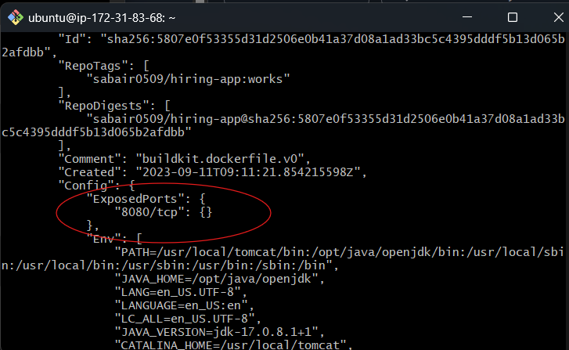

Why we need this
Our dynamic port mapping will be:
Container port: 8080 ← application port
Host port: 0 ← dynamic
Protocol: TCP
For example, ECS might create:
EC2 Instance
│
├── Host :32768 → Container :8080
├── Host :32769 → Container :8080
└── Host :32770 → Container :8080
Then the ALB sends traffic to those dynamically assigned ports.

Because the ECS task uses:
Network mode:
awsvpc
the task receives its own ENI and private IP address.

11. CloudWatch Logging
CloudWatch logging was enabled for the container.
Log driver:
awslogs
Log group:
/ecs/hiring-app
AWS region:
us-east-1
Stream prefix:
hiring-app
Configuration:
Log Driver:
awslogs

awslogs-group:
/ecs/hiring-app

awslogs-region:
us-east-1

awslogs-stream-prefix:
hiring-app
This allows us to view Tomcat/application logs directly through CloudWatch.


12. Application Verification Through Logs
CloudWatch logs showed that Tomcat successfully started.
Important log:
Initializing ProtocolHandler ["http-nio-8080"]
This confirmed that Tomcat was listening on:
8080
The logs also showed:
Deploying web application archive
[/usr/local/tomcat/webapps/hiring.war]
and:
Deployment of web application archive
[/usr/local/tomcat/webapps/hiring.war]
has finished
Therefore:
Tomcat → Running
Port 8080 → Listening
hiring.war → Successfully deployed
The application context is:
/hiring/
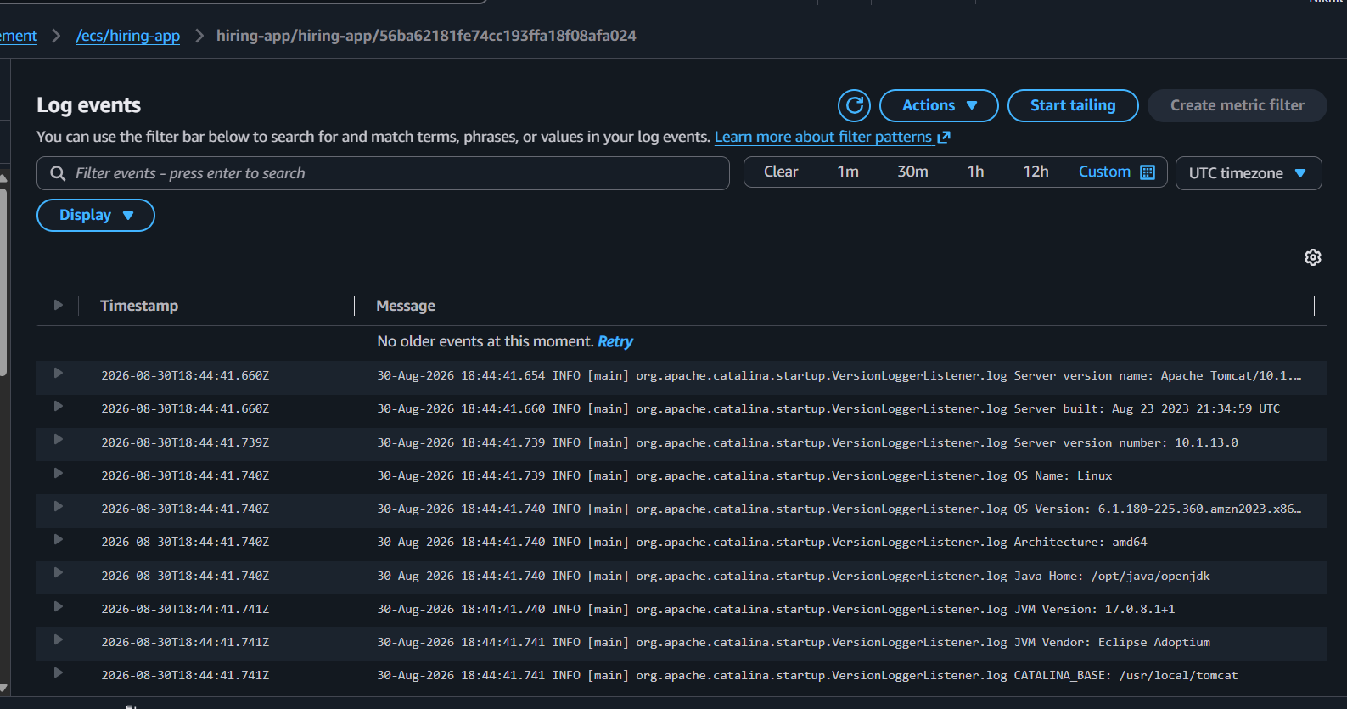

13. Target Group
A target group was created for the ECS service:
hiring-app-tg-ip-1
Target type:
IP
This is important because the ECS task uses:
awsvpc
network mode.
Therefore the target group must use:
Target type = IP
and not:
Target type = Instance

Create Target Group
Go to:
AWS Console
→ EC2
→ Target Groups
→ Create target group

1. Choose target type
Select:
Instances
Because we're using:
ECS → EC2 launch type

2. Basic configuration
Enter:
Target group name:
hiring-app-tg
Protocol:
HTTP
Port:
8080
IP address type:
IPv4
Select your VPC:
10.0.0.0/16

3. Health checks
Configure:
Health check protocol:
HTTP

Health check path:
/
Port:
Traffic port
So the ALB will effectively check:
ALB
↓
Target
↓
Dynamic host port
↓
Container :8080
↓
/
If the application returns a successful response, the target becomes:
Healthy ✅

4. Advanced health-check settings
For now, you can leave the defaults.
For example:
Healthy threshold: 5
Unhealthy threshold: 2
Timeout: 5 seconds
Interval: 30 seconds
Success codes: 200
Don't change these unless your application requires something different.

5. Register targets
You may see a section asking you to:
Register targets
Leave the target registration empty and create the target group.
Why?
Because ECS will automatically register the tasks and their dynamic ports when we create the ECS service.
For example, ECS will eventually create registrations like:
EC2-1 :32768 → Task 1 :8080
EC2-1 :32769 → Task 2 :8080
EC2-1 :32770 → Task 3 :8080

EC2-2 :32768 → Task 4 :8080
EC2-2 :32769 → Task 5 :8080
EC2-2 :32770 → Task 6 :8080

6. Create target group
Click:
Create target group
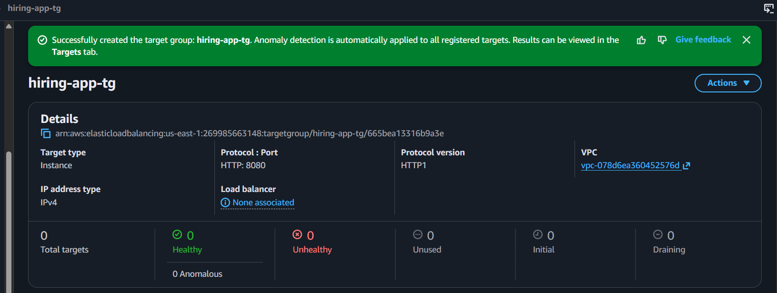
You should now have:
hiring-app-tg
with:
Protocol: HTTP
Port: 8080
Health check: /

An initial error occurred because an instance-type target group was selected:
target group is incompatible with selected task definitions
network mode which is set to awsvpc
target type is instance but must be ip
This was fixed by creating/selecting an IP target group.

14. ALB Creation
An Application Load Balancer was created:
hiring-app-alb
The ALB is placed in public subnets across:
us-east-1a
us-east-1b
This provides high availability at the load-balancer layer.
We need:
Application Load Balancer
It will be:
Internet
|
↓
ALB :80
|
↓
Target Group
|
↓
ECS Tasks
The ALB should span at least:
AZ-a
AZ-b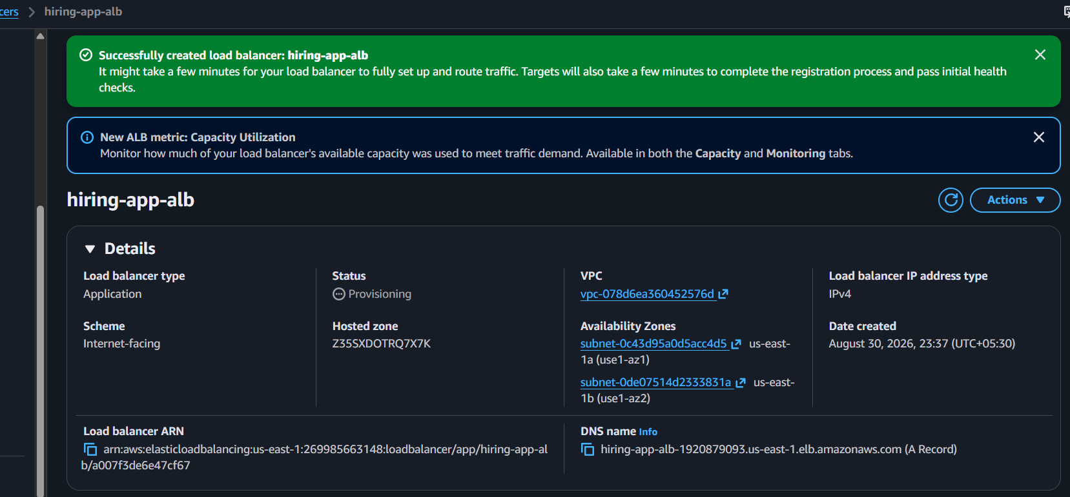

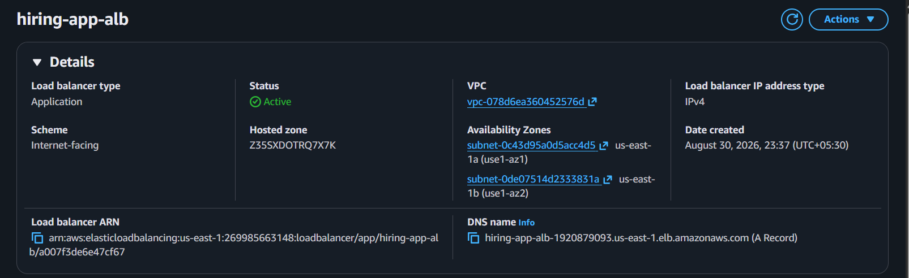

15. ALB Listeners
Two listeners were initially present:
HTTP :80
HTTP :8080
The important listener for normal application access is:
HTTP :80
The port 80 listener was initially forwarding to the wrong target group:
hiring-app-tg
while the healthy ECS targets were registered in:
hiring-app-tg-ip-1
This caused:
503 Service Temporarily Unavailable
The port 80 listener was corrected to forward to:
hiring-app-tg-ip-1
Final traffic flow:
HTTP :80
|
↓
hiring-app-tg-ip-1
|
↓
ECS tasks :8080

16. Target Group Health Check
Initially the health check was:
Protocol: HTTP
Path: /
Port: Traffic port
Success codes: 200
The targets were showing:
Unhealthy
Health check failed with code: 404
This was an important finding.
It proved that:
ALB → ECS Task
network connectivity was working, but the requested path / did not exist.
Since the application was deployed as:
hiring.war
the application context is:
/hiring/
Therefore the health check was changed to:
Protocol: HTTP
Path: /hiring/
Port: Traffic port
Success codes: 200
After changing the health check path, the targets became:
Healthy
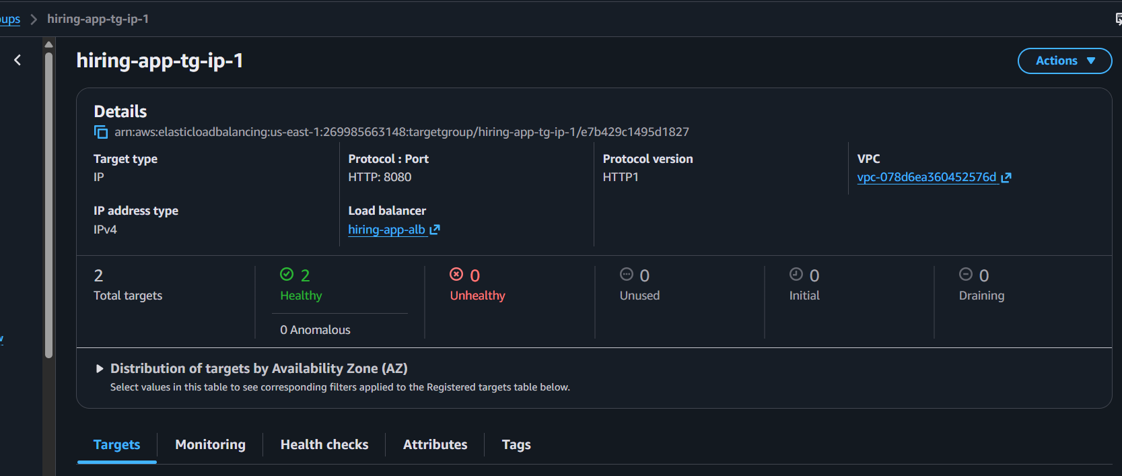

17. Troubleshooting Security Groups
The ECS task Security Group was checked.
Inbound rule:
TCP 8080
Source: hiring-alb-sg
Outbound rule:
All traffic
Destination: 0.0.0.0/0
The ALB Security Group was also checked.
Outbound:
All traffic
Destination: 0.0.0.0/0
Therefore Security Groups were not blocking the application traffic.

18. Network ACL Verification
The private subnet Network ACL was checked.
Inbound:
Rule 100
All traffic
0.0.0.0/0
ALLOW
Outbound:
Rule 100
All traffic
0.0.0.0/0
ALLOW
Default rule:
*
DENY
Because rule 100 matches first, traffic is allowed.
Therefore the Network ACL was not blocking the ALB-to-ECS communication.

19. Reachability Analyzer
AWS Reachability Analyzer was used to verify network connectivity between the ALB and ECS task.
Source:
ALB ENI
eni-0d878818872a89916
Destination:
ECS Task ENI
eni-0a789d74daf3bed81
The analysis result was:
REACHABLE
This confirmed that the network path between the ALB and ECS task was working.
Architecture verified:
ALB ENI
|
| TCP
↓
ECS Task ENI
10.0.12.180
|
↓
Container :8080

20. ECS Task Networking
One running task was verified with the following configuration:
Task ID:
56ba62181fe74cc193ffa18f08afa024

Network mode:
awsvpc

ENI:
eni-0a789d74daf3bed81

Private IP:
10.0.12.180

Subnet:
Private-2

Security Group:
hiring-ecs-sg
The target group also contained:
10.0.12.180:8080
Therefore the registered target matched the running ECS task.
Another target was:
10.0.11.17:8080
which belongs to the other Availability Zone.

21. Final Working Target Configuration
The target group now contains two targets:
10.0.11.17:8080
us-east-1a
Healthy

10.0.12.180:8080
us-east-1b
Healthy
This demonstrates that the application is currently running across two Availability Zones.
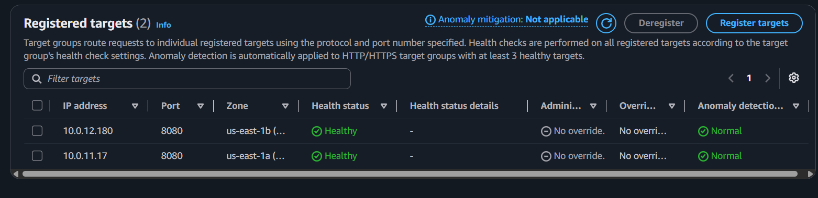

22. Application Access
After correcting the ALB listener and target group, the application became accessible through:
http://<ALB-DNS>/hiring/
For example:
http://hiring-app-alb-xxxxxxxx.us-east-1.elb.amazonaws.com/hiring/

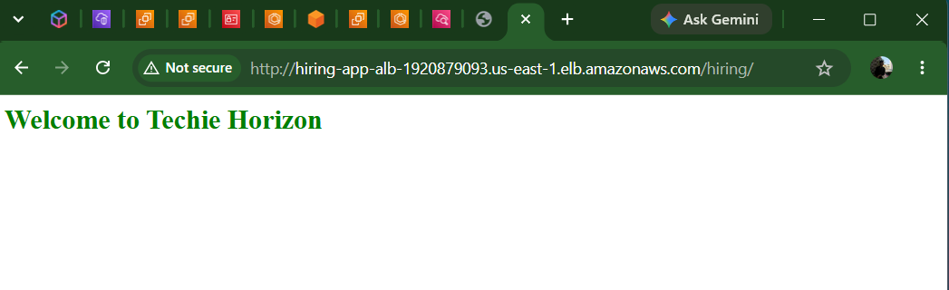
The successful request flow is:
Browser
|
| HTTP :80
↓
Application Load Balancer
|
↓
hiring-app-tg-ip-1
|
├───────────────┐
↓ ↓
ECS Task 1 ECS Task 2
us-east-1a us-east-1b
10.0.11.17 10.0.12.180
| |
↓ ↓
Tomcat :8080 Tomcat :8080
| |
└───────┬───────┘
↓
/hiring/

Next we complete the 6-task high-availability requirement. Since your application is already working.

Step 23 — Check your EC2 capacity
Go to:
ECS → Clusters → hiring-app-cluster → Infrastructure
Open Container instances.
You should see your EC2 instances.

For each instance, check:
Instance type
CPU available
Memory available
Availability Zone
Status

Why we're checking this
Each task requires:
0.5 vCPU
1 GiB memory
For 6 tasks, ECS needs at least:
6 × 0.5 vCPU = 3 vCPU
6 × 1 GiB = 6 GiB memory
And we need capacity across both AZs.
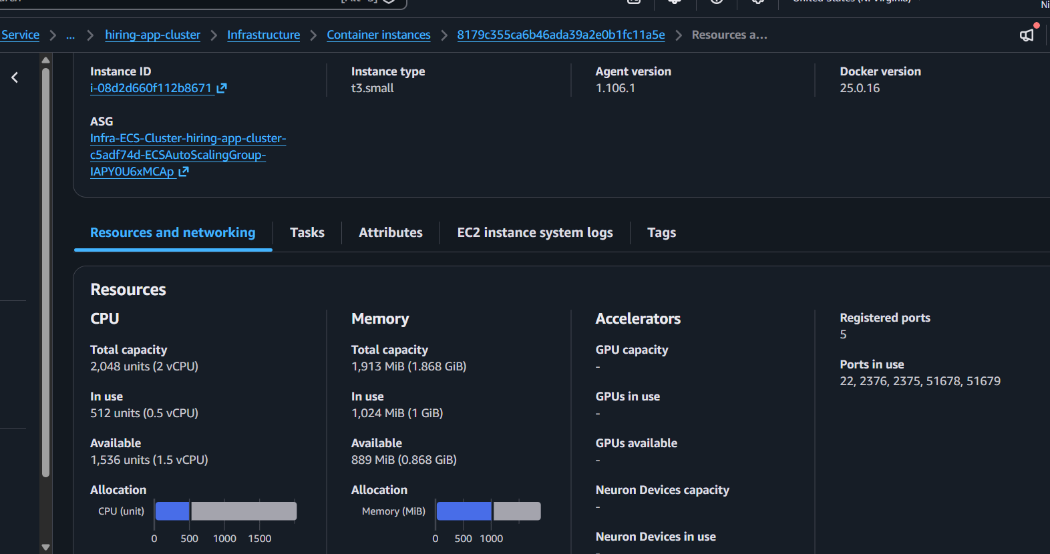
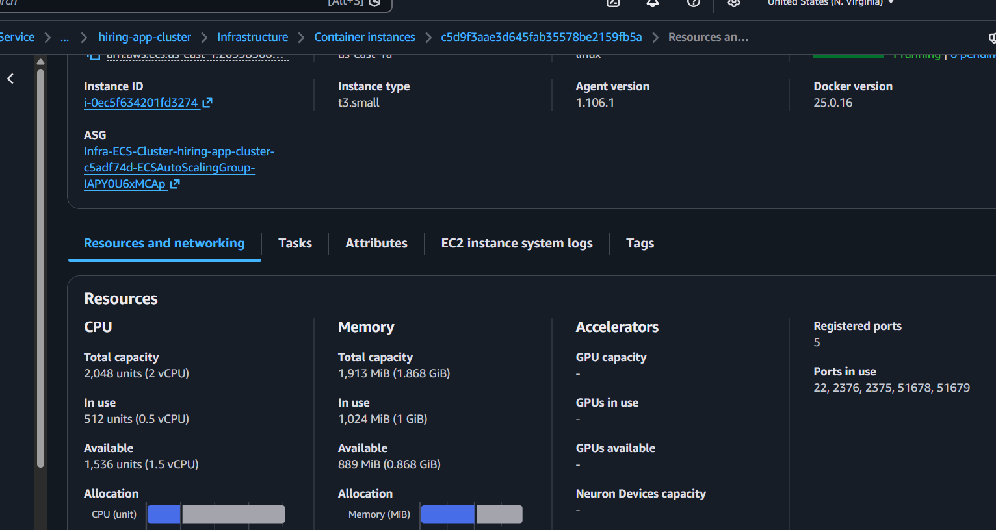

Step 24 — Check the Auto Scaling Group
From:
ECS → Cluster → Infrastructure → Capacity providers
click:
Infra-ECS-Cluster-hiring-app-cluster-...AsgCapacityProvider...
Then find the associated Auto Scaling Group.
We need to know its:
Minimum capacity
Desired capacity
Maximum capacity
For example, you might currently have:
Min: 1
Desired: 1
Max: 1
If Max = 1, ECS cannot automatically add enough EC2 capacity for six tasks.
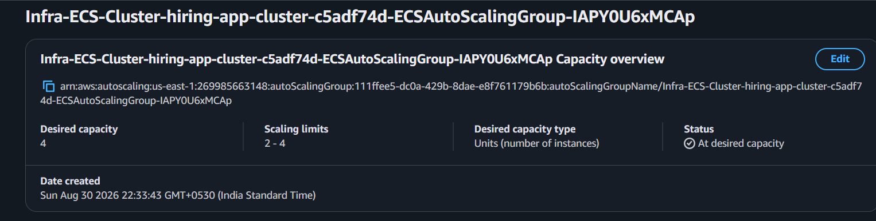

Step 25 — Change ECS Service Desired Count to 6
Go to:
ECS → Clusters → hiring-app-cluster → Services → hiring-app-service
Click:
Update service
Find:

Desired tasks
Change:
Current:
2

New:
6
So enter:
Desired tasks = 6
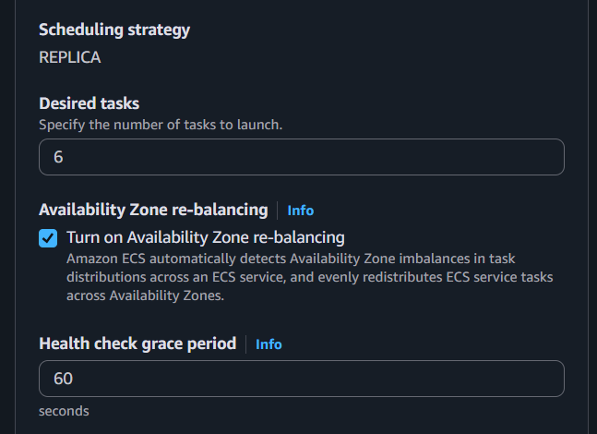

Important
For now, don't change:
- Task definition
- Networking
- Target group
- Load balancer
- Health check
- Container configuration
Those are already working.
Click Update / Create depending on what your console shows.

Step 26 — Watch the tasks
Go to:
ECS → hiring-app-service → Tasks
You should eventually see:
Desired: 6
Running: 6
Pending: 0
Initially you may see:
Desired: 6
Running: 2
Pending: 4
That's normal while ECS is launching the additional tasks.
Wait until:
Running: 6
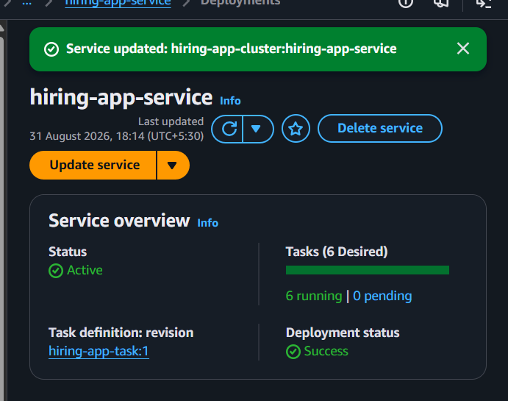

Step 27 — Check the Target Group
Go to:
EC2 → Target Groups → hiring-app-tg-ip-1 → Targets
You want to see:
Target 1 → Healthy
Target 2 → Healthy
Target 3 → Healthy
Target 4 → Healthy
Target 5 → Healthy
Target 6 → Healthy
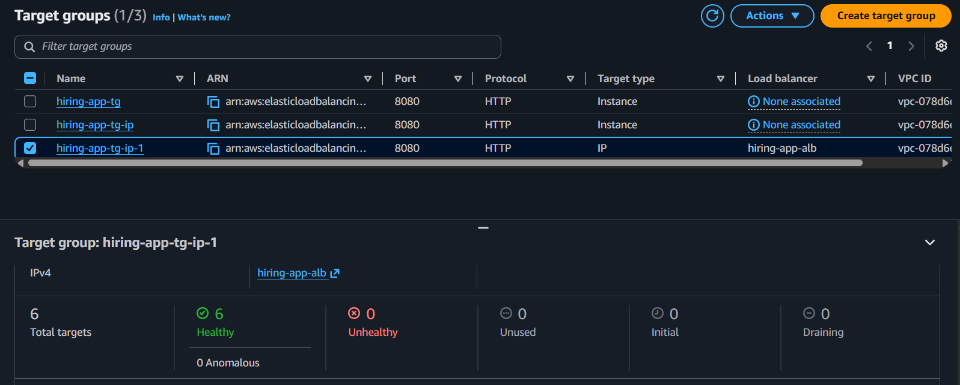
The targets should have different private IP addresses because each awsvpc ECS task gets its own ENI/IP.
Example:
10.0.11.x:8080 Healthy
10.0.11.x:8080 Healthy
10.0.11.x:8080 Healthy

10.0.12.x:8080 Healthy
10.0.12.x:8080 Healthy
10.0.12.x:8080 Healthy

Step 28 — Verify both AZs
In the target group, check the Zone column.
We want tasks in both:
us-east-1a
us-east-1b
For example:
ALB
|
Target Group
|
┌───────┴───────┐
↓ ↓
us-east-1a us-east-1b
| |
3 Tasks 3 Tasks
The exact distribution may not be exactly 3/3, but both AZs should have running tasks.
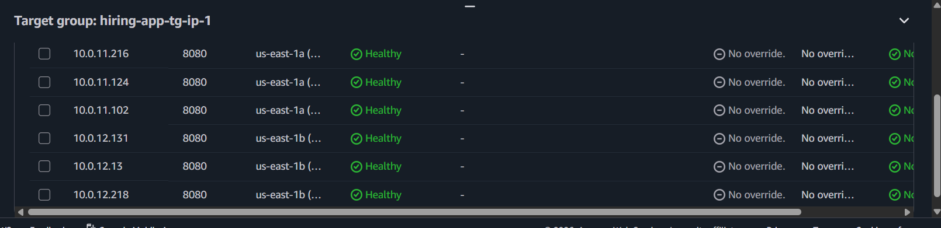

Step 29 — Test the application
Open:
http://<ALB-DNS>/hiring/
It should still load the application.
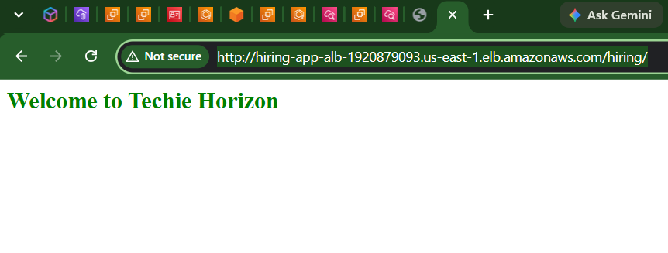
Then refresh several times.
The ALB will distribute requests among the healthy ECS tasks.

our success criteria
At the end, we want:
ECS Cluster
↓
4 EC2 instances
↓
6 ECS tasks
↓
6 healthy ALB targets
↓
2 Availability Zones
↓
Application accessible

Outcome
The hiring-app application was successfully deployed on an Amazon ECS cluster using EC2 capacity with an Application Load Balancer (ALB).
Successfully deployed the hiring application on an Amazon ECS cluster using EC2 capacity, with an Application Load Balancer and IP-based target group. Six ECS tasks are running across multiple Availability Zones, all six targets are healthy, and the application is accessible through the ALB URL at /hiring/.

